|  |  |  |  |
| --- | --- | --- | --- |
| **CS102** | **Spring 2018/19** | Project Group | 1A |
| Instructor: | **David Davenport** |  |  |
| Assistant: | Çağlar Öksüz |  |  |

|  |  |  |
| --- | --- | --- |
| **Criteria** | **TA/Grader** | **Instructor** |
| Presentation |  |  |
|  |  |  |
|  |  |  |
|  |  |  |
| Overall |  |  |

~ Droneer ~

BAZUKA

Baykam Say, Alp Üneri, Zübeyir Bodur, Uğur Erdem Seyfi, Ege Kaan Gürkan, Agil Aliyev

|  |
| --- |
| UI Design Report  ( version 1.0 )  19 March 2019 |

# Introduction

Learning programming can be a difficult and often boring task for beginners. In order to solve this problem, we have proposed a programming game called Droneer. In this game, players program a space drone to engage other drones in combat. They write the code beforehand in a separate ide-like part of the game and then complete different combat challenges slowly increasing in difficulty. This way, players can learn programming while having fun. On the following pages, there will be a storyboard for the user interface of the game as well as several screens the player will encounter during gameplay.

# Storyboard

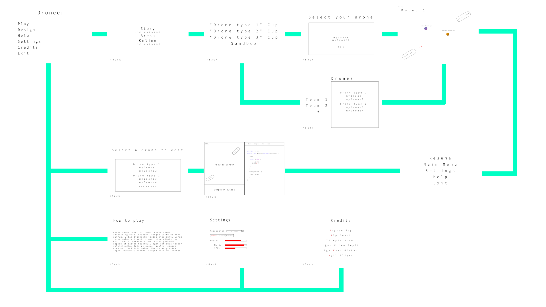

# The Screens

## Welcome

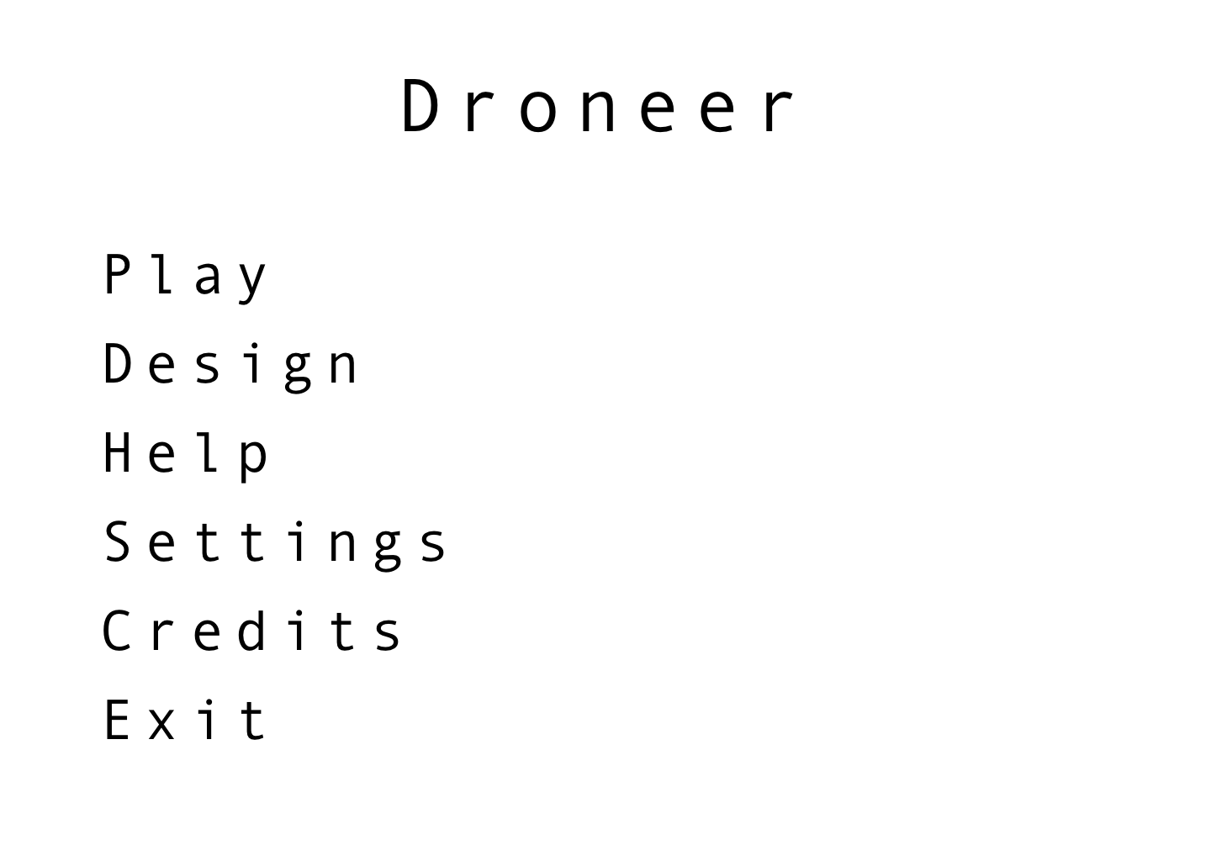

This is the main screen that the player will face when first launching the game. The player will have the option to choose one of the following:

1. Play: The player will be directed to the game mode selection screen.
2. Design: The player will be directed to the drone selection screen in order to select which drone they would like to edit.
3. Help: The player will be directed to the help screen.
4. Settings: The player will be directed to the settings screen.
5. Credits: The player will be directed to the credits screen.
6. Exit: Quits the game.

## Play

### Game Mode Selection



This is the screen that the player will be directed to if the “Play” option is chosen from the welcome screen. The player will have the option to choose one of the following game modes:

1. Story: This option will not be available.
2. Arena: The player will be directed to the arena mode selection screen.
3. Online: This option will not be available.

### Arena Mode Selection

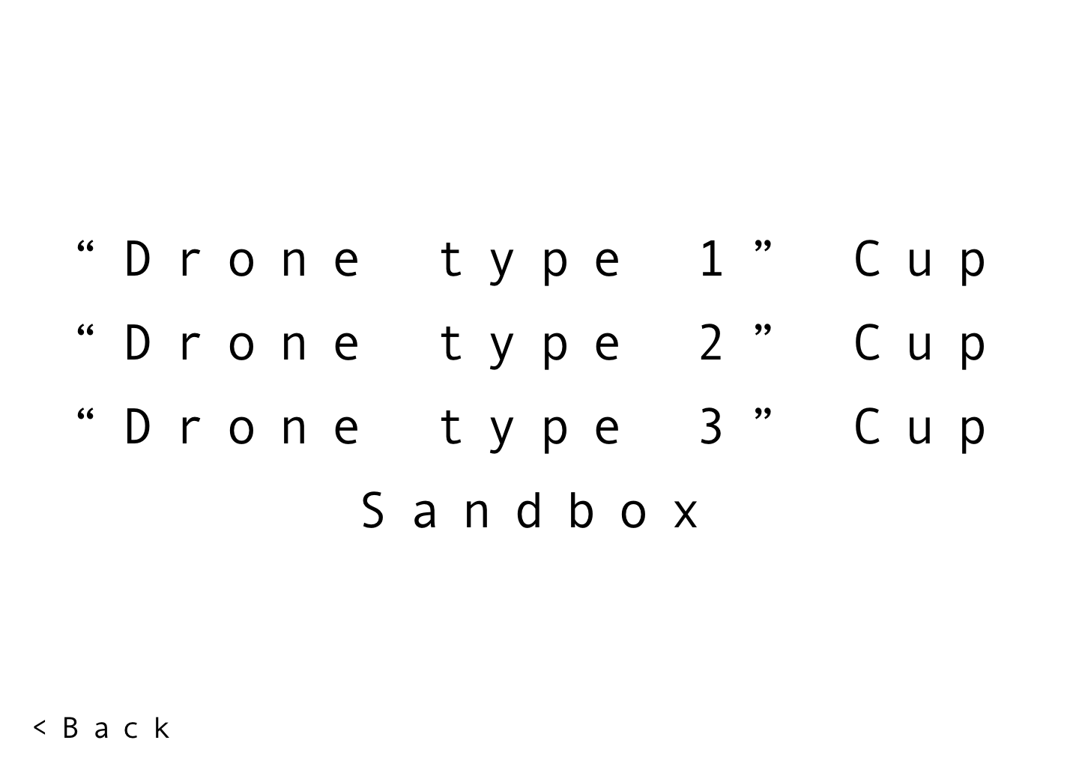

This is the screen the player will be directed to when the “Arena” option is chosen from the game mode selection screen. The player will have the option to choose one of the following.

1. Drone type X Cup: There will be several types of drones differentiating in shape, size, subsystems etc. This arena mode will feature a continuous supply of increasingly difficult enemy drones that the player’s drone will fight against one after another. After a predetermined round of matches if the player’s drone is still alive, the player wins. Else, the player loses.
2. Sandbox: The player will be able to create several teams consisting of whichever drone types that they would like in the team.

### Drone Cups

### Cups Drone Selection

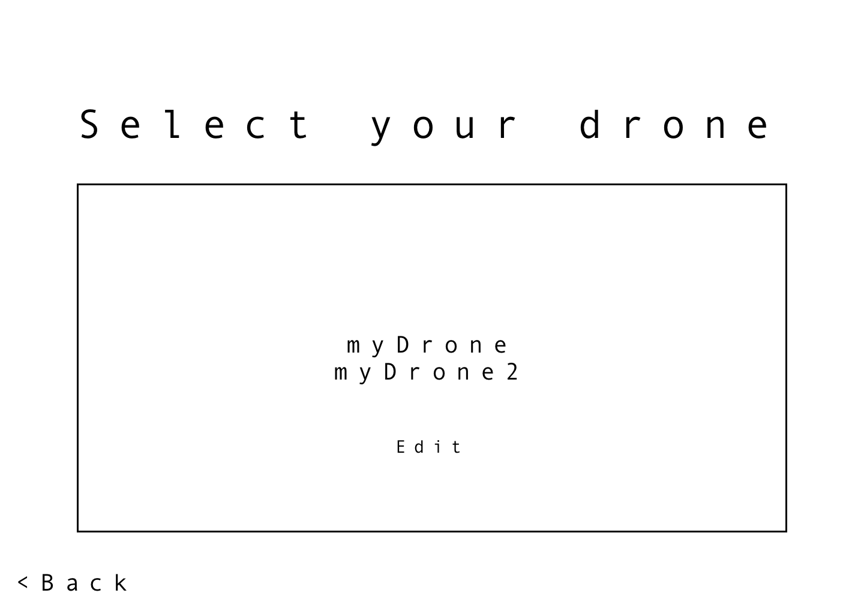

This is the screen the player will be directed to if the “Drone type X Cup” option is chosen from the arena mode selection screen. The player will have the option to choose which drone he or she wishes to enter the arena with. Or edit one of the drones, which directs the player to the edit screen.

### Sandbox

### Sandbox Drone Selection

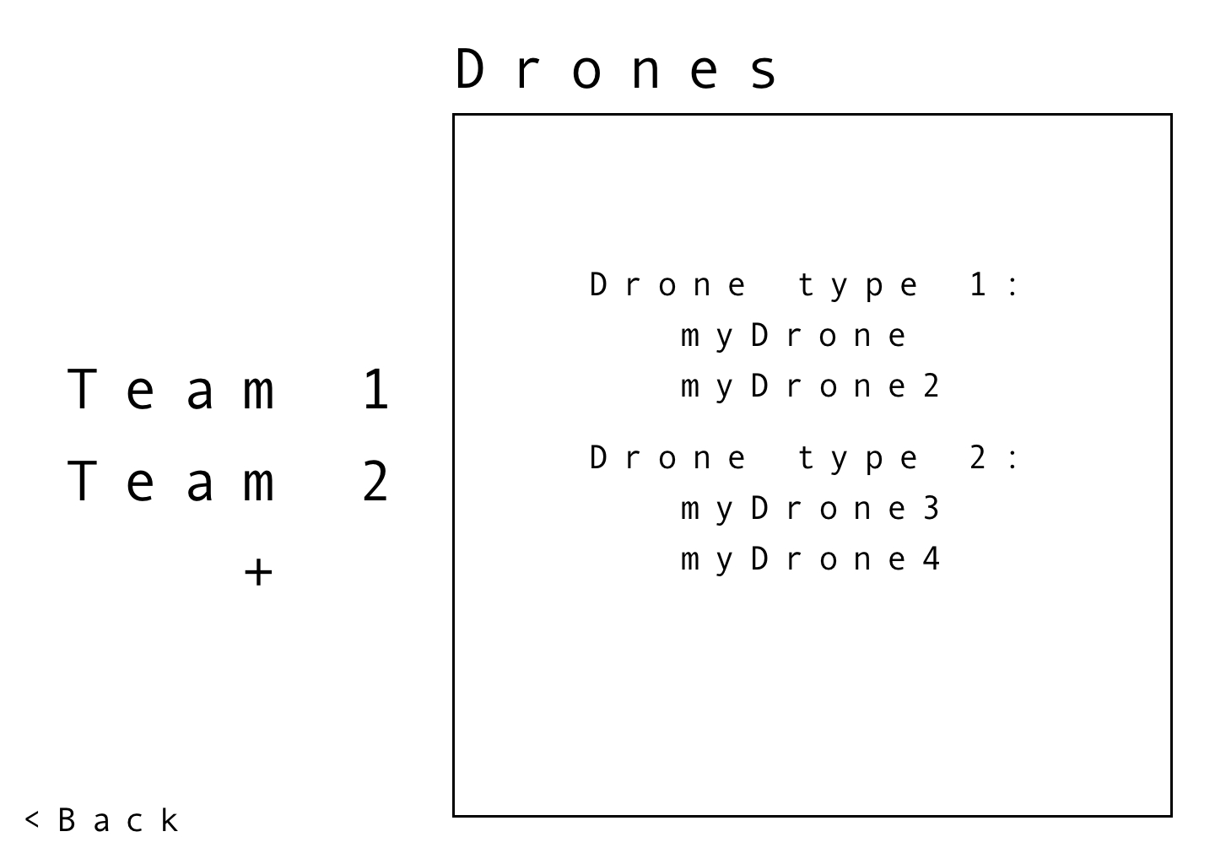

This is the screen the player will be directed to if the “Sandbox” option is chosen from the arena mode selection screen. The player will have an option of creating different teams and adding drones to them.

### Battle

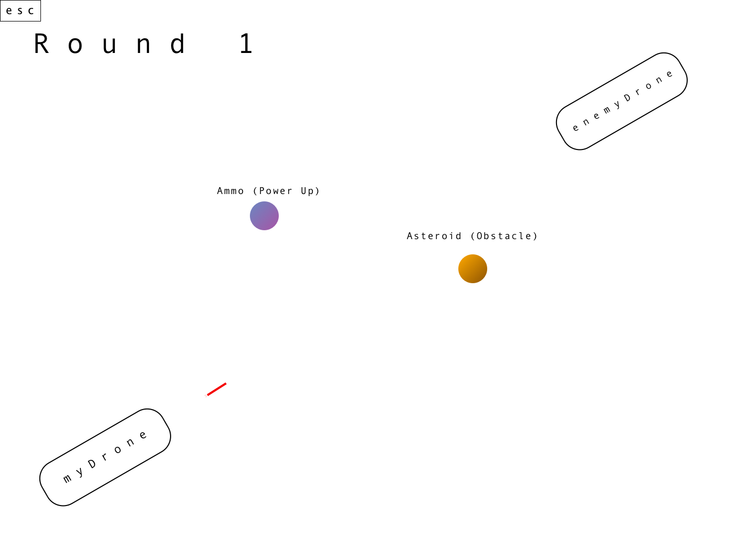

This is the screen that the player will be directed to after choosing either the drone they wish to enter the arena with (if the Drone type x Cup option is chosen) or creating the teams that they desire (if the Sandbox option is chosen). Here the player will be able to see their drones engage other drones in combat using the algorithms that they have designed the drones with beforehand (using the Design option from the main menu).

## Design

### Drone Selection

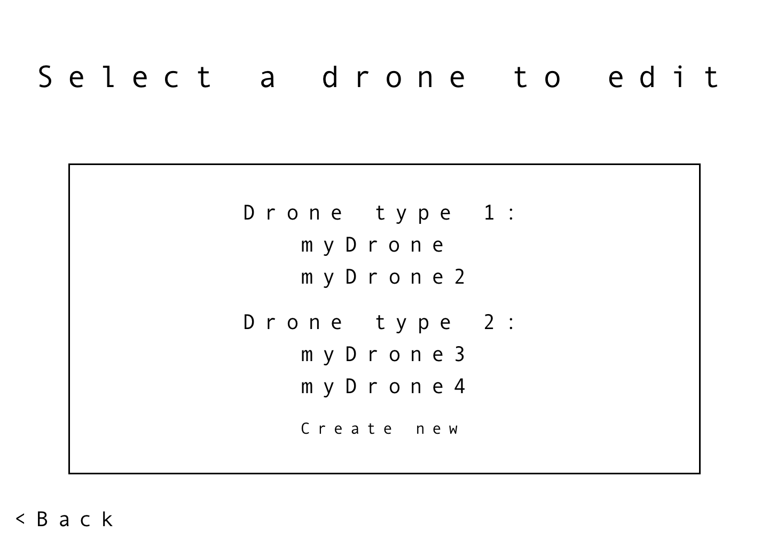

This is the screen the player will be directed to if the “Design” option is selected from the welcome screen. The player will have the option to choose which drone he or she wants to modify (edit its code) or create a new drone.

### Drone Editing

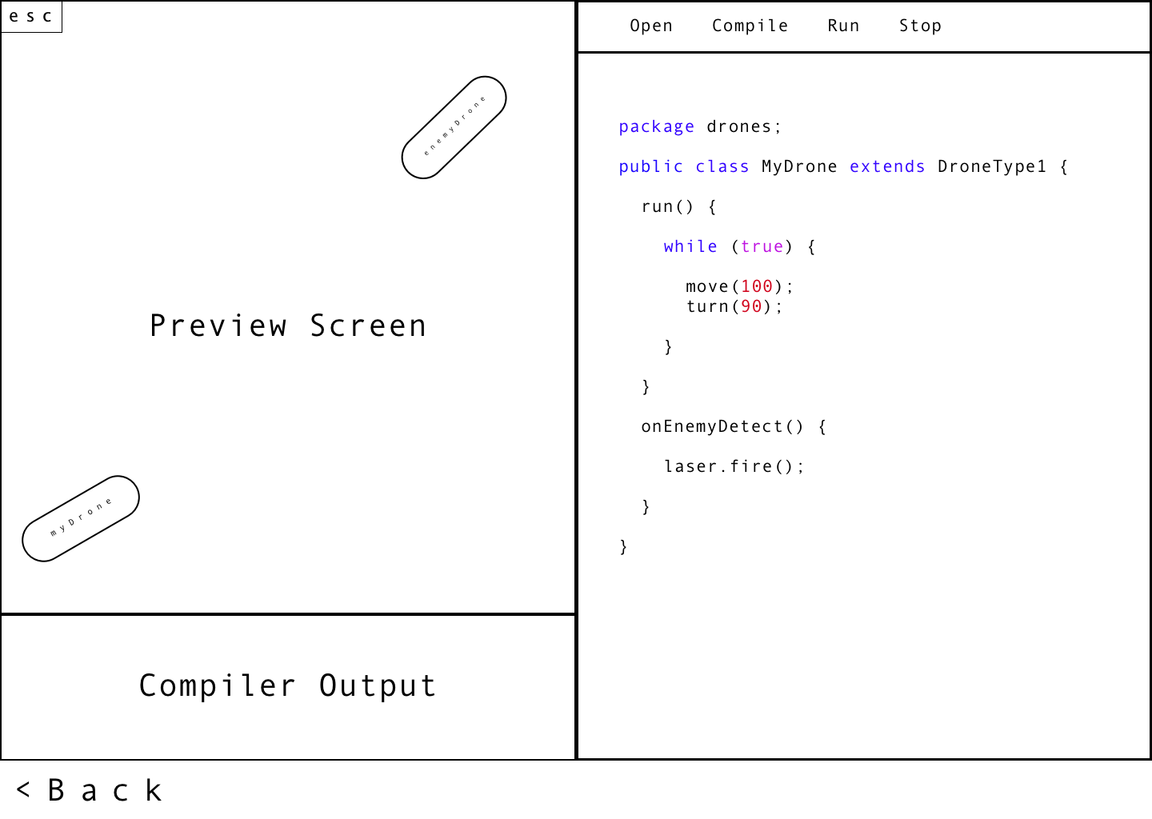

This is the screen the player will be directed to after selecting a drone from the previous screen. The player will be able to start modifying the chosen drone. They will have the option to tweak with the code of the drone (the editor screen on the right), see the errors in their code and debug problems using system.out.print() statements (the compiler output screen on the bottom), as well as preview how the changes they have made to the drone’s code affect its gameplay (preview screen on the left). They will have the option to open a document that they have saved the drone’s code to, compile and run the code, as well as stop the process should they encounter some kind of problem (toolbar on the top right).

## Help

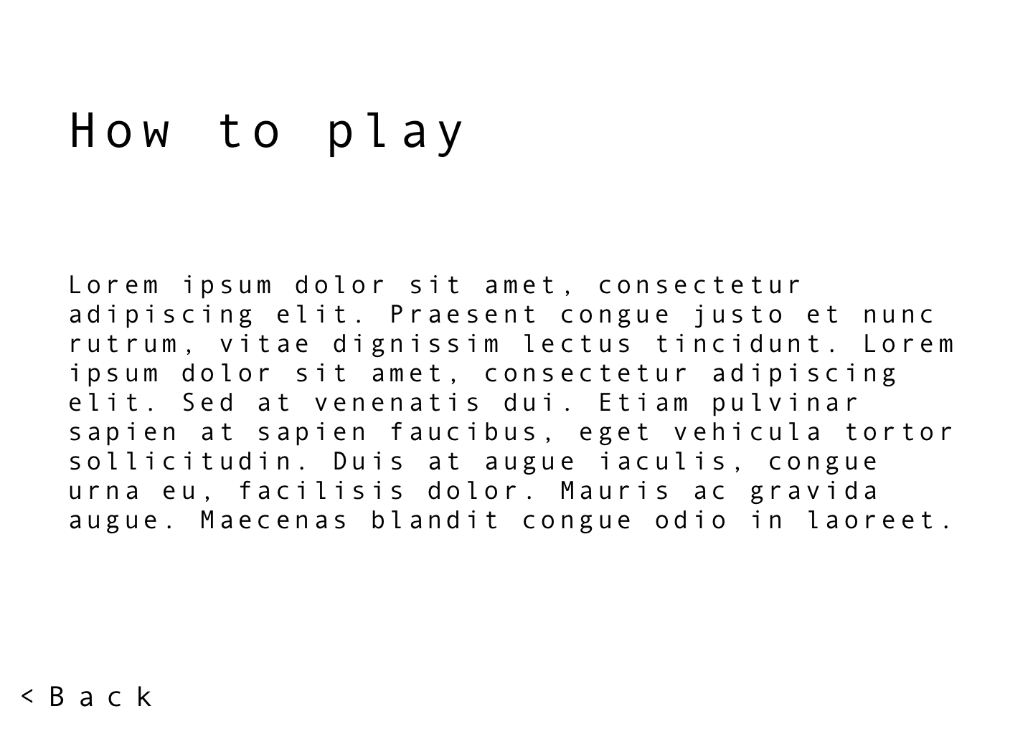

This is the screen the player will be directed to if the “Help” option is selected from the welcome screen. This screen will contain information on how to play the game. The player will be able to learn about the working principles of the game here.

## Settings

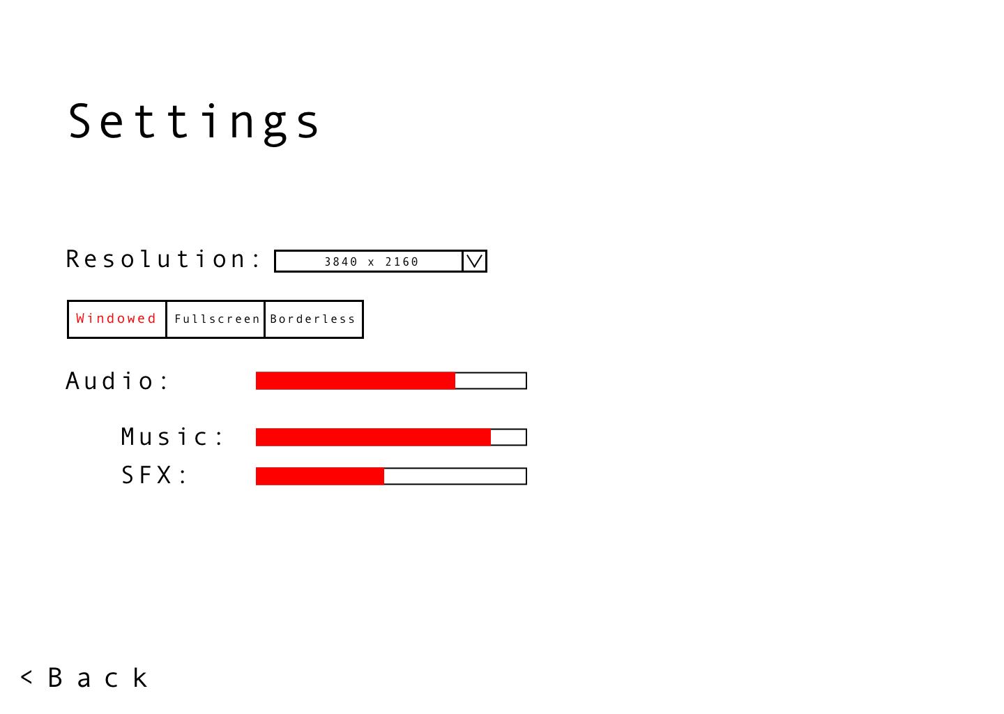

This is the screen the player will be directed to if the “Settings” option is chosen from the welcome screen. The player will be able to adjust resolution, volume level, and window type here.

## Credits

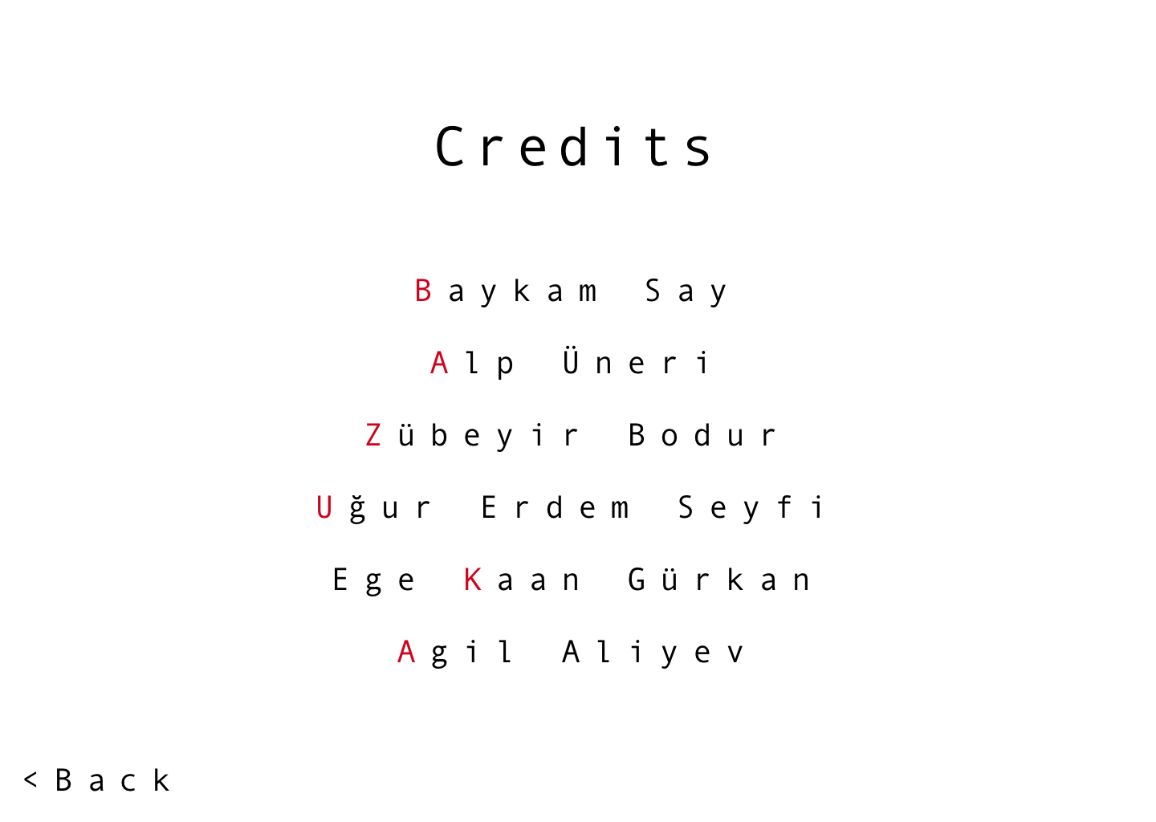

## ESC Menu

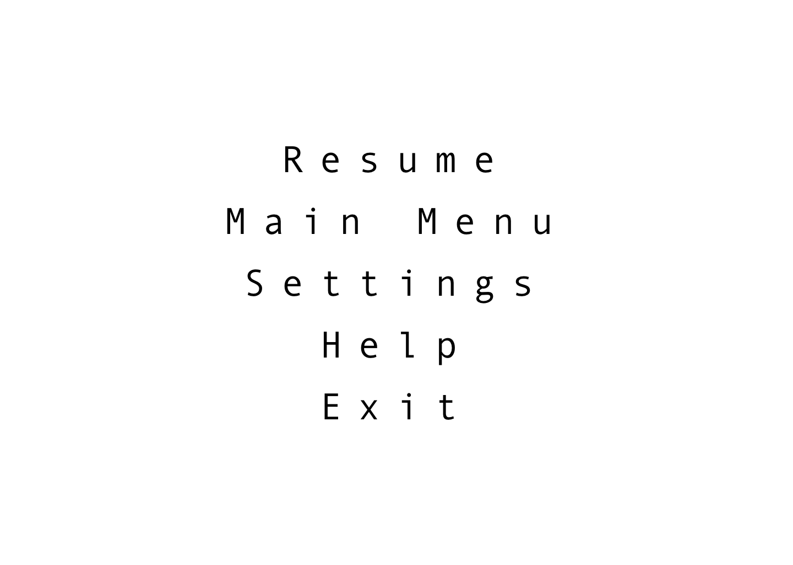

# Summary & Conclusions

This programming oriented game will allow for players without any background in programming to learn and master its basics in a fun and stimulating environment, as well as allow for more seasoned programmers to improve upon their existing knowledge whilst also having a good time. In Droneer, we are aiming for a user-friendly interface that will allow even the most inexperienced player to quickly start with the game.